Name: Gayatri Ashok Gaikwad

Roll No.: 35018

Batch: A

**Assignment No. 04**

**Title:** Find a procedure to transfer the files from one virtual machine to another virtual machine

* Download the Ubuntu VMDK image from <https://app.vagrantup.com/bento/boxes/ubuntu-18.04>
* Download and install Oracle's Virtual Box <https://www.virtualbox.org/wiki/Downloads>

**Steps Launch new Virtual Machine:**

* Open Oracle VM VirtualBox Manager

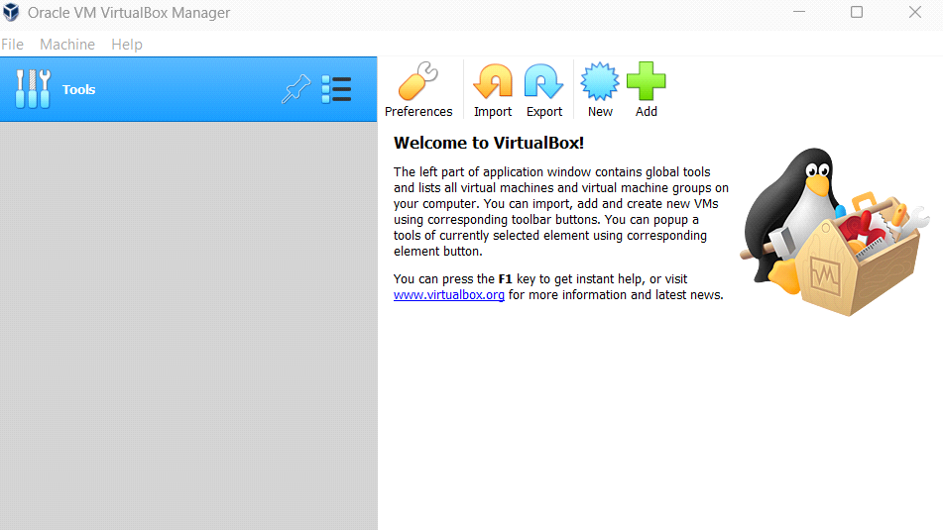

* Click on new

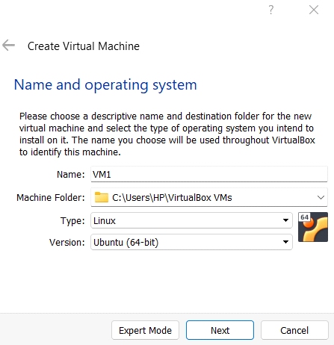

* Select **Use an existing virtual hard disk file**

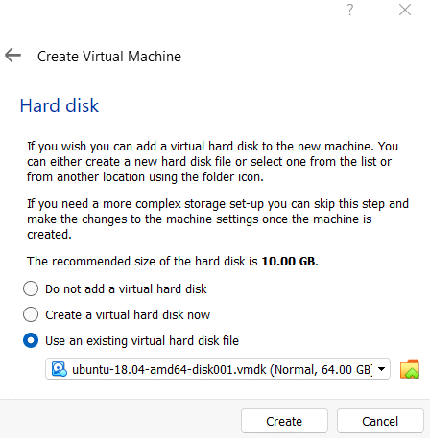

* Now add Nat Network: File → Preferences → Network → Ok

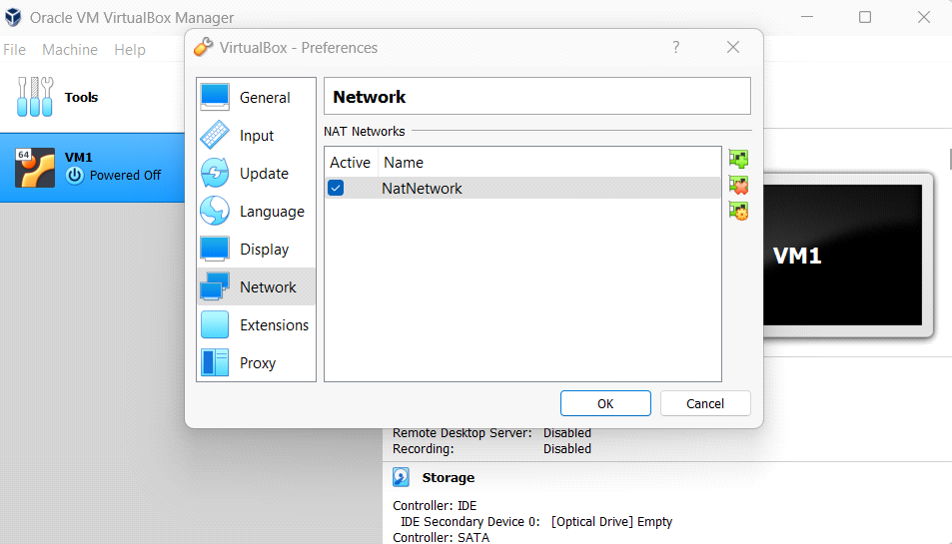

* Go to VM Settings → Network → Attached to → Nat Network → Ok

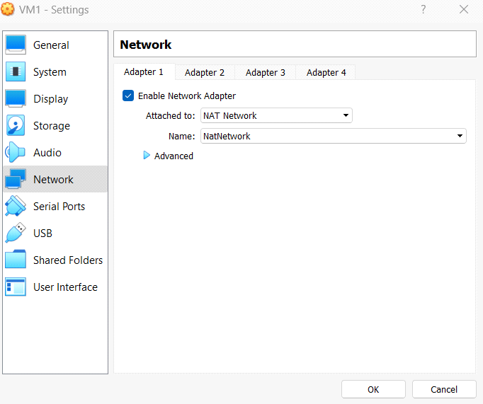

Repeat the same process and create VM2

**Pass data between Virtual Machines:**

* Start VM1 and log in using the **vagrant** username and password

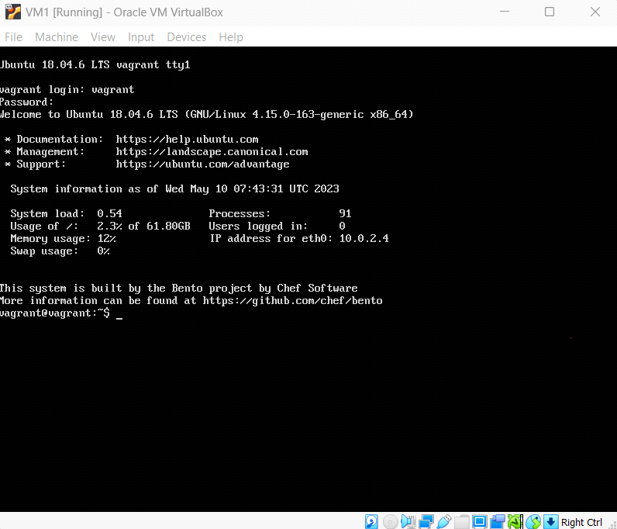

* Create a file using **touch myfile.txt**
* Write data in a file using **nano myfile.txt**
* Run **ifconfig** command it will give the address of the system in this case address of VM1 is **10.0.2.4**
* Start the VM2 login into it and get its address using the **ifconfig** command **10.0.2.5**
* Run **scp myfile.txt vagrant@10.0.2.5:/home/vagrant** command in VM1

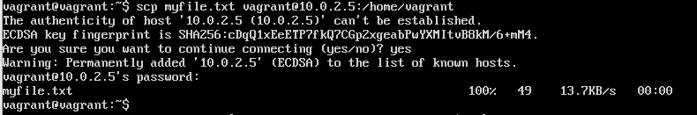

* Run **ls /home/vagrant** in VM2 and check myfile.txt is present there and see the content of the file using the **cat myfile.txt** command

